**SYSTEM FEATURES:**

**Login:**

Enter a user name and a password to log in.

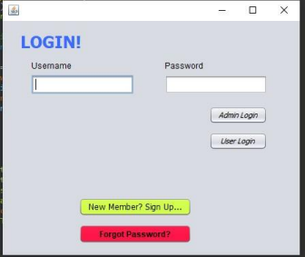

**Admin Panel:**

A window that shows all of the admin entity's functions in the system.

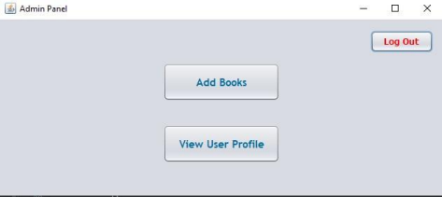**Add Books:**

The admin can change the books, and we can add books from new publishers. If there is a new  version of any book, we can add it.

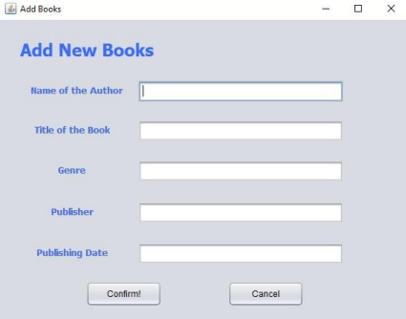**View user profile (Admin):**

Admin can look at the user's profile. Admin can only see how much a user was fined or check the list of  books that were given to that user.

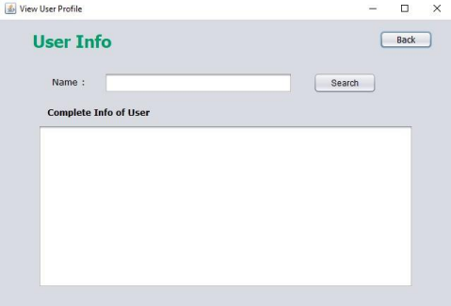**User Panel:**

A window that shows the user all of the things they can do in the system.

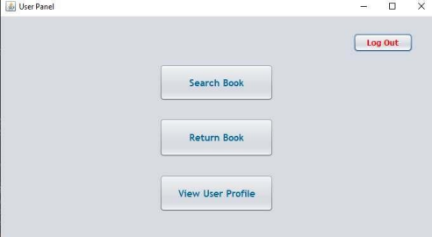**Search for books:**

Users can look for books by typing in the title, publisher, and edition.

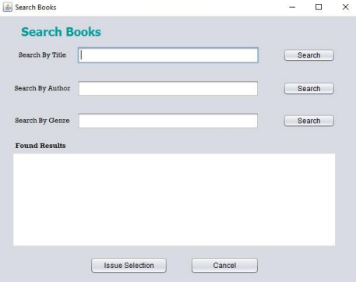**Returns Book:**

If the user reads the book, he should click the "Return" button and give the book back. 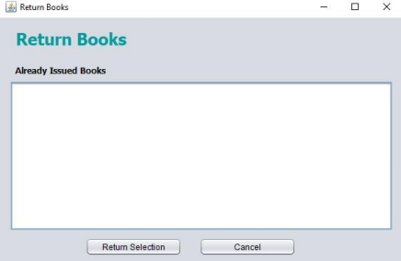**View user profile (User):**

The user can see how many books he has checked out, if he has any fines, and if he needs to bring the  book back or not.

